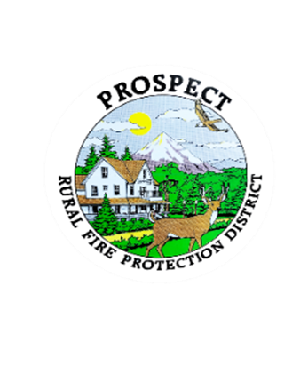

Agenda

Regular Board Meeting

October 21, 2024 at 7pm

Prospect School - Media Center

1. Call to Order (Karen Wickman)

2. Roll Call

3. Approval of September Minutes (Karen Wickman)

4. Emergency additions to the Agenda.

5. Financial Report (Bob Jones)

6. Chief’s Report (Lyle Neville)

7. Levy update (Melissa Taylor)

8. Fire Chief Annual Evaluation (Clay Thomas)

9. SDAO Special Districts Class (Karen Wickman)

10. Finalize plans for work sessions (Karen Wickman

A. Work on Fire Chief Contract, Job Description,

Goals and Expectations and Annual Evaluation.

B. Policy and Procedure Books

11. Public comment, limited to 3 minutes per speaker.

12. Adjourn

Next Board of Directors meeting, 7:00pm, Nov. 18, 2024

BOD agenda Items due by October 31, 2024